Performance Testing Using JMETER

**# Test 1 :-**

* **166 Users for 60 sec**
* **Throughput 2.8/sec**

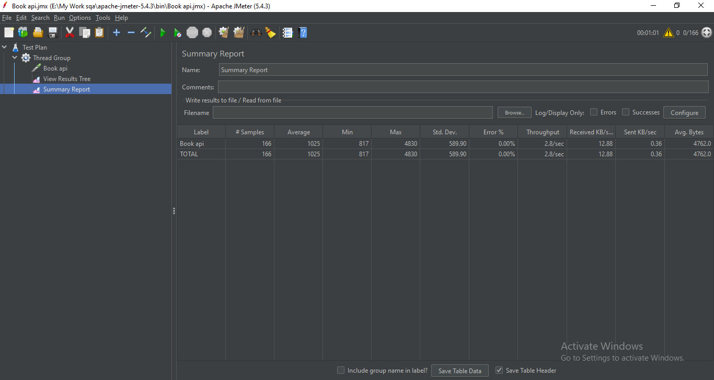

***Fig 1: testing 166 users for 60sec.***

**# Test 2 :-**

* **834 Users for 300 sec**
* **Throughput 2.8/sec**

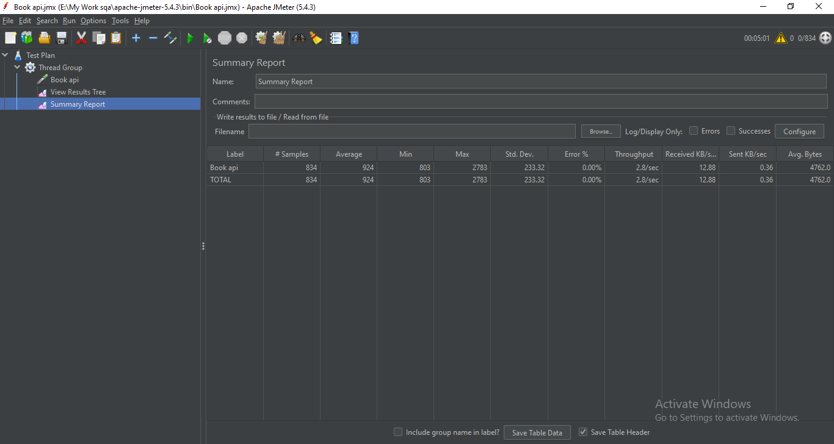

***Fig 2 : testing 834 users for 300sec.***

**# Test 3 :-**

* **1668 Users for 600 sec**
* **Throughput 2.8/sec**

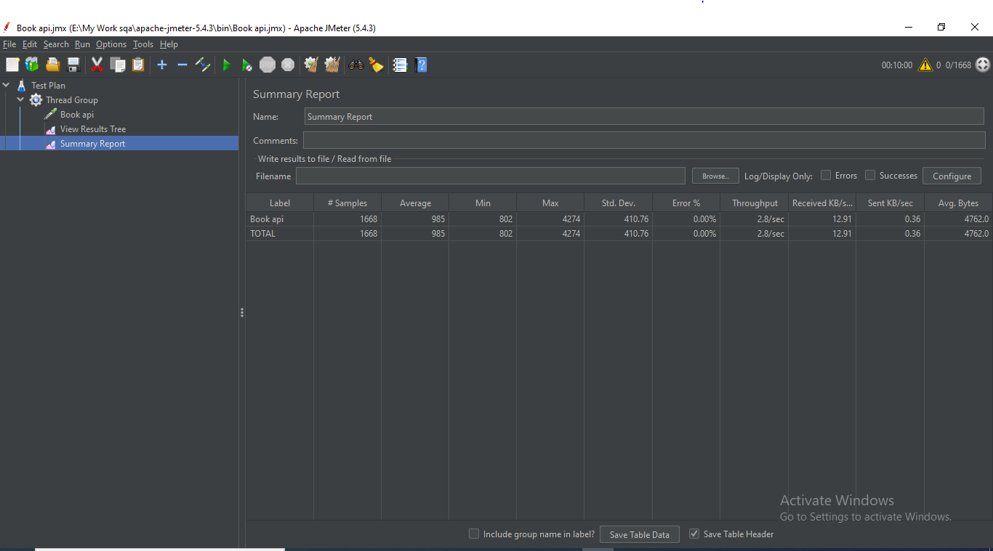

***Fig 3 : testing 1668 users for 600sec.***

**# Test 4 :-**

* **2502 Users for 900 sec**
* **Throughput 2.8/sec**

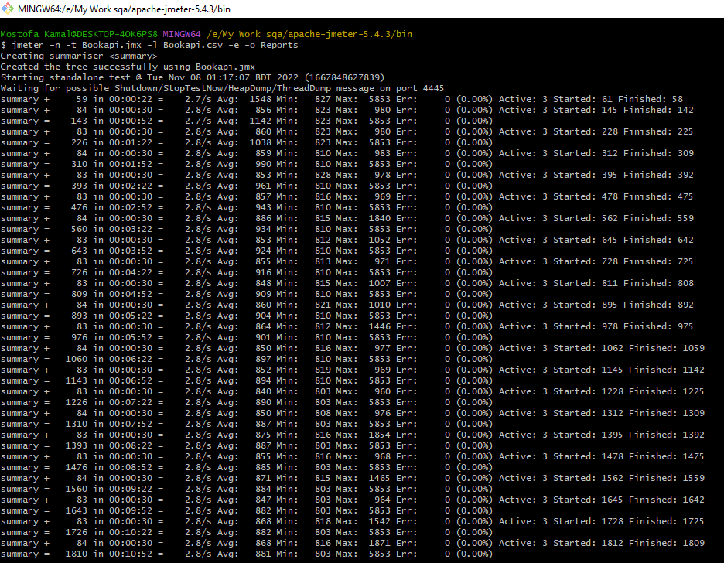

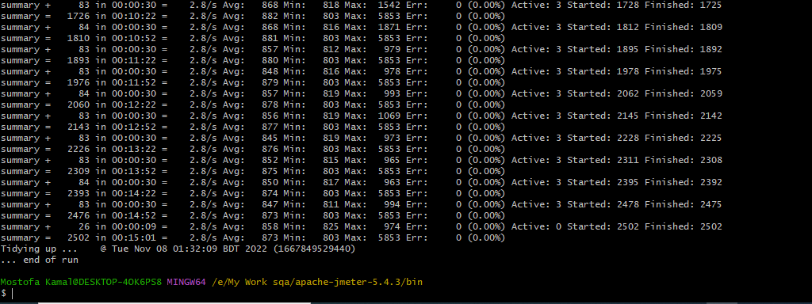

***Fig 4 : testing 2502 users for 900sec.***

**Report Summary : Testing 2502 users for 900sec**

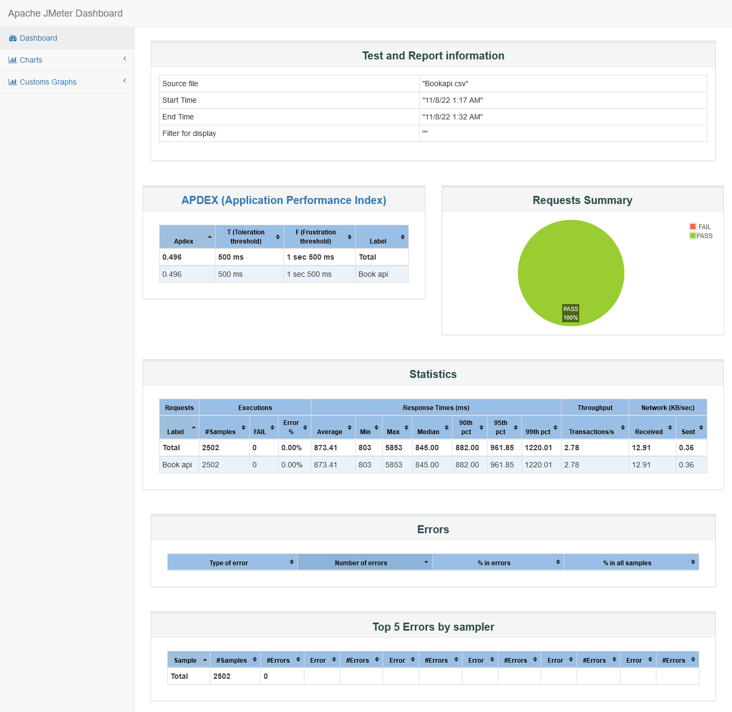

***Fig 5 : report summary for testing 2502 users for 900sec.***